**OPERS BPM 8.5.6 Upgrade Runbook**

1. Backup VMs after shutdown all BPM environment related hosts
   1. Backup Jobs located in SYS0.ZVM.BACKUP
2. Perform Database Server Upgrade to 10.5
   1. <http://www-01.ibm.com/support/knowledgecenter/SSEPGG_10.5.0/com.ibm.db2.luw.qb.upgrade.doc/doc/t0023856.html>
   2. Please refer to the DB2 10.5 upgrade runbook document for more detailed description of the process
3. Backup Dmgr profiles.



1. Backup PS01 profiles.



1. Upgrading the Process Server Deployment Manager
   1. Copy the Installation Binaries or mount the LXREPO share to individual servers you are upgrading
   2. 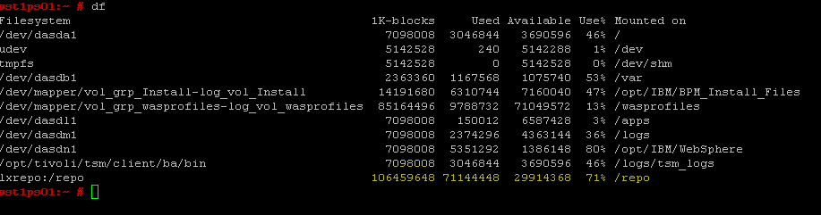
   3. Upgrade Installation Manager if required
   4. 